# Steady State AC Network Analysis



## Intro

### ILOs

1. Know when steady-state AC network analysis is applicable
2. Understand the phasor representation for voltage and current signals, and how to convert between it and the time-domain signal.
3. Understand how to determine the complex impedance of resistors, capacitors, and inductors.



1. Understand how to use AC network analysis to determine steady-state voltage or current anywhere in a circuit.
2. Understand how to create and read plots of signals (current or voltage) vs. time
   1. Determine amplitude, peak-to-peak value, and RMS value
   2. Determine phase difference between two signals and whether one is leading or lagging the other
3. Understand how to use simulated and actual waveform generators and oscilloscopes to create and measure steady-state AC networks

Example Circuit:

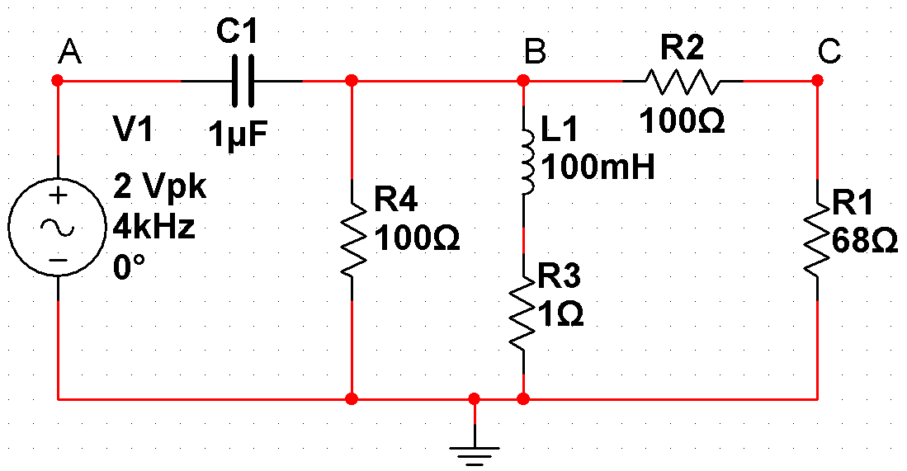

### Topic 2 Videos:

1. Analytical: <https://www.youtube.com/watch?v=24V0rVW3ClY&list=PLhbHWgMknRJT_eKLFXB843NkaNHfJ37Pw&index=10>
2. Multisim: <https://www.youtube.com/watch?v=rRr5Zplrf7Y&list=PLhbHWgMknRJT_eKLFXB843NkaNHfJ37Pw&index=11>
3. Lab Skills: <https://www.youtube.com/watch?v=EJFTPWAq6Iw&list=PLhbHWgMknRJT_eKLFXB843NkaNHfJ37Pw&index=11>
4. Hantek Lab Modification: <https://youtu.be/G59WT4kK6eE>
   1. Note: the circuit in the Hantek video for this week is different than the sample lab circuit used in the other videos. See the end of the video if you'd like to know which circuit Peter is building here!

### Deliverables

Note: As always, your full objective for this topic is to review these notes, the videos, practice problems, live class sessions and forum content, then to write-up creating and tri-solving a variation problem of the week's topic that demonstrates you've mastered the content. With that all still in mind, following are some specific guidelines & tips for this week.

See the Outline and Deliverable Rubric files for information for the write-ups in general. Specific tasks for your H2 deliverable are as follows:

1. Build a circuit of similar complexity as the sample lab; that is,
   1. Only one supply: an AC voltage source with some frequency you like that's over 1 kHz and less than 20 kHz, has no DC offset and an amplitude of ≤ 2.5 V.
   2. At least one of each component (resistor, capacitor, and inductor)
   3. At least two meshes
   4. At least 4 components total
2. Start by finding the internal resistance of your inductor*, and include that in your circuit. Also, measure the resistance values of your resistors before starting.
3. Make your tri-solve objective to
   1. find both the [nontrivial] current through and voltage across
      1. one resistor,
      2. one capacitor, and
      3. one inductor,
   2. and express these [6] results both
      1. in the phasor domain and
      2. as time domain signals.
   3. Note: take your supply to be the reference point for 0° phase.
   4. Note: depending on how you lay out the circuit, some of these currents and voltages may be the same (e.g., the resistor and inductor are in series so have the same current, the capacitor and resistor are in parallel so have the same voltage, etc.)
   5. Note: with the scope, you can only measure voltage *at a point* relative to your ground, so to find voltage *across* a component you'll need to find the voltage on each side of it (relative to ground) and subtract one from the other. To find current, you'll need to find the voltage across a series resistor and divide by its resistance.
4. Analytically solve your circuit [by working in the phasor domain] two ways:
   1. By using either Kirchoff's laws OR using voltage dividers, and
   2. By using either mesh analysis OR nodal analysis
   3. Note: work in the phasor domain to find the output phasors, which should agree with your two methods. Then convert the output phasors to the time domain for comparison with your other methods.
   4. Note: though you need to solve it analytically two ways, you only need to explain one of them (of your choosing) in detail (and even then, explain it at a level appropriate to show the TA that you know what you're doing, NOT so detailed as to teach someone unfamiliar how the method works). The second way you can just show the diagram and equation setup clearly then jump to the solution (which hopefully is a confirmatory check of your first method!)
5. For your multisim solution, solve the circuit using both:
   1. single frequency AC analysis, and
   2. any one of the oscilloscopes.
   3. Note: in newer versions of multisim the analysis type is moved from where it is in the [video](https://www.youtube.com/watch?v=rRr5Zplrf7Y&list=PLhbHWgMknRJT_eKLFXB843NkaNHfJ37Pw&index=15); in Multisim 14.2, it's in the simulate menu:
   4. 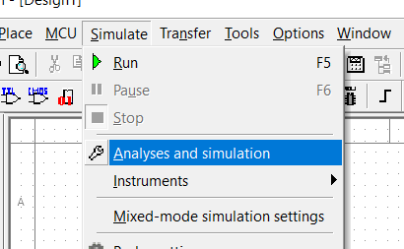
   5. (After using *Single Frequency AC*, remember to change the analysis type back to the default *Interactive* or the scope simulation won't work).
6. For your physical build, measure your circuit using the oscilloscope.
   1. Note: You will need to use the scope, not the multimeter (even for the current measurement). Partly to learn how to use the scope, but partly because multimeter only measures AC at certain low frequencies around 60 Hz. By the way, at frequencies where the multimeter *does* work, it outputs measures in RMS, not amplitude. The Hantek version of the lab video shows how you *would* use the multimeter to measure current, but you should do it with the scope (see the next note).
   2. Note 2: in order to measure AC current with the scope, you need to measure **voltage** and do a calculation (i.e., ). For this reason, you will need a resistor next to ground in any part of the circuit that you want to make a current measurement (since  is a real number so the voltage across it is in phase with the current through it).
   3. Make sure that the circuit you design has a predicted current amplitude out of your voltage supply under 100 mA. If it's way too high you need to add higher impedance components.
   4. Remember that the low side of your hantek's waveform output (Gen Out) and the lowside of its scope probe inputs (CH1 & CH2) are all connected together inside the case, so if you hook up the probes backwards (i.e., put the ground from a probe somewhere that's not the ground of your supply) you'll be shorting out components and possibly shorting out your hantek output, which can damage it.
7. For your analysis,
   1. remember that if you didn't use the measured input values you need to re-calculate your predicted output values (using at least one of your analytical methods, but without explaining it as fully as in that section) using measured inputs so you can compare your results. You can again potentially get minor bonus marks (up to 11/10 on analysis) and major superstar engineer points if you use the error propagation formula to determine the uncertainty on your predicted outputs.
   2. Make sure to discuss the relationship between voltage and current phase for each component and what this means.

Additional Notes on the Physical Inductors:

1. *Remember that the physical "inductor" you have is actually more like an inductor in series with a resistor, and accounting for that unavoidable series resistance in your analytical and multisim model is necessary for them to agree with your measurements. (To clarify it a bit, it's not like someone has built a deliberate resistance into that package before the inductor, it's that the wire coil that produces inductance is not a superconductor so has some resistance as well. Really the inductance and resistance are evenly distributed along the wire length in that device, so while you can model it as a resistor and inductor in series and talk about the total voltage across both, it's not truly two physically separate components so it doesn't make sense to talk about the voltage across just one of them).
2. Note: make sure you're using the right inductor and capacitors before proceeding! See the lab videos.
   1. This is an inductor:   
      
   2. This is **not** an inductor:   
      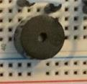  
      This is a **buzzer**. If you hook this up instead of an inductor, your circuit won't work and you might spend hours trying to figure out why your Hantek is suddenly making noise.
   3. This is also **not** an inductor:  
      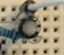  
      This is an electrolytic **capacitor**. **Firstly and Finally**: you don't need to use electrolytic capacitors for this course. There's no benefit from using them here, even when we're in DC, and if you mess it up it can explode acid and shrapnel into your eyes.  
      One side (the one with the negatives) must be hooked up to a lower voltage than the other side. If you hook it up backwards or use it in AC, it can eventually become a near-short circuit, possibly (depending on the circuit you have it in) letting a lot of current through a small resistance, turning a lot of power into heat, boiling the acid and [exploding](https://youtu.be/rbCXKhhzBN0?t=212) from the gas expansion. This is because they get the high capacitance by putting a thin strip of metal coiled up in a bath of acid in such a way that a super-thin insulating film forms on the metal from a chemical reaction and acts as the dielectric. i.e.,   
      Capacitor "Plate" 1 = metal coil

Capacitor "Plate" 2 = acid  
Dielectric between the "plates" = thin ceramic (e.g., oxide, sulphide, etc.) film on the metal. The film that forms in this reaction is denser than the metal itself, so unlike rust (iron-oxide) which can eat right through a metal, this forms a thin layer and stops further chemical reaction (like aluminum oxide).  
If you put on the voltage the correct way, it reinforces the film, or leaves it alone.  
...but if you put the voltage on backwards, it runs the chemical reaction the other way, removing the film, and eventually making a conducting path right from the metal to the acid: touching the plates together. Then much more current flows, causing heat and evaporating acid in a condensed space, and boom: exploding acid & shrapnel.

## Steady State AC Network Analysis

### Capacitors & Inductors

**Capacitor:** A capacitor is a device that stores charge separation. **Capacitance** of a capacitor is the charge it can store per applied voltage difference between the plates: ****, and is itself only a function of geometry of the capacitor and the dielectric constant of the separation between its "plates" (and *not* a function of either the charge or the voltage). Because the capacitor voltage is tied to the charge on its plates, neither can change instantaneously. Current is rate of change of charge, so we could also express the capacitor equation as .

**Inductor:** An inductor is a device which creates a strong magnetic flux for a given current, and therefore opposes changes in current flow through Faraday's law. Because of this, the current in an inductor can't change instantly. **Inductance** of an inductor is the voltage it produces between rate of change of current and EMF (i.e., voltage *v*) produced across it: .

Properties table:

|  |  |  |
| --- | --- | --- |
|  | Capacitors | Inductors |
| Differential i-v |  |  |
| Integral i-v |  |  |
| DC steady state: | Open circuit | Short circuit |
| In series: |  |  |
| In parallel: |  |  |
| Energy (work): |  |  |
| Complex Impedance  (explained in the Phasor section soon) |  |  |

### Time Dependent Sources

Sinusoidal signal: . Where *A* is the amplitude,  is the angular frequency (in rad/s), and  is the phase angle (AKA phase constant, AKA phase shift). Note the following:

1. While  is the *phase constant* or *phase shift*, technically the *entire* argument  of the sinusoid is the *phase* (which is time-dependent).
2. A cos or sin are only different by a phase constant, since 
3.  where *f* is the [cyclical] frequency (number of cycles the signal goes through per unit time; Hz)
4.  where  is the period (the time it takes for one cycle)

**Average (AKA "mean") value of a periodic signal:** .

The positive and negative swings of a sinusoid average out to zero. If the centre of the swings (and therefore the average) *isn't* zero, the signal has a constant offset (often called its "DC offset").

**Root-Mean-Square (RMS) of a periodic signal:** 

For a sinusoidal signal of amplitude *A* (i.e., ), the RMS value of the signal turns out to be .

/***** Proof:



The middle step () comes from either the half-angle identities (, and noting that after integrating you get the same number at each end of the range) or from noting that  is on average the same as  over an integer number of periods, and their sum is 1, so the average of either alone must be 1/2.

*****/

Since power dissipated in a resistor scales with voltage or current *squared* (), it turns out the average power dissipated in a resistor by *any* periodic signal is the same as the power that would be dissipated by a DC current & voltage at the rms values of the periodic current & voltage.

(i.e., if the voltage across a resistor is , then the average power dissipated in it is . This is true whether  is sinusoidal, a square wave, DC, etc.)

### Circuit Containing Energy Storage Elements (Capacitors & Inductors)

If you apply a sinusoidal source (AC) to a circuit containing resistors, capacitors, and inductors, the response (voltage and current) anywhere will have two parts:

1. The **transient** part: depends on the initial conditions of elements and disappears after enough time
2. The **steady-state** part: sticks around and is periodic at the same frequency as the source (but not necessarily the same phase)

You *can* solve for the outputs by using Kirchoff's laws (or any analysis technique from chapter 3) combined with the i-v relations for the passives (resistors, capacitors, and inductors). This leads to first (if there's resistors + inductors or capacitors but not both) or second order (if there's both inductors and capacitors) differential equations in time. But if you only need the steady state solution then it's much faster to use the phasor approach from the rest of this chapter (even if you do care about the transient response, you can add it to the steady-state solution using superposition. We'll look at the transient solution in Topic 3).

### Phasor Solution: Circuits with Sinusoidal Sources

When everything in the circuit is sinusoidal at the same frequency (as it will be in steady-state in response to a sinusoidal source), it's tedious to write and manipulate sinusoidal functions. A faster way is to use **phasor** representation:



Here,  is the phasor representation for , where  (we use *j* rather than *i* because *i* is for current in circuits class. Most programming languages do this too, but there it's because *i* is for iterator variables). Note that the time-dependence and frequency are *implied*, but not written. To determine the actual signal somewhere from the phasor there, you multiply by  and then take the real part:



(voltage  is the real part of the voltage phasor  after it's been multiplied by the complex time-dependence , where *V* is the voltage amplitude.)

### Ohm’s Law Continued: Phasors and Impedance

With phasors, we can generalize Ohm's law to include capacitors and inductors and say , where **V** is the voltage phasor, **I** is the current phasor, and **Z** is the [complex] impedance of the passive(s) elements. The impedances for each passive element are given below:

, , .

/*** Derivation:

We can determine what the impedance is for each passive from the i-v relations for resistors, capacitors, and inductors:



(since *R* is real)



and 

Note: it's not actually valid for complex numbers to declare that . However this "proof" is really a consistency check and therefore actually intended to run backwards: we're trying to determine what to define the complex impedance of a resistor as so that the phasor solution will give the correct solution in the time domain, and in that direction the proof is valid:



This shows that defining  in the phasor domain gives solutions that are *consistent* with Ohm's law in the time domain.

For capacitors,



So if , then , therefore the capacitor impedance for consistent results must be , since



Similarly, inductors with  lead to :



****/

The inverse of impedance is called admittance, .

### AC Circuit Analysis

To determine the steady-state values of the voltage and current at parts of a circuit in AC,

1. Convert the sinusoidal sources to phasor representations (If you have multiple sources at *different* frequencies you need to redo this whole solution method for each different frequency because the frequencies change the impedance. The final voltages and currents will still add at any given time via superposition, but the phasors can't be directly added since they're referring to different frequencies),
2. Find the impedance of each passive element,
3. Solve for the voltage & current phasors of interest (using the network analysis from chapter 3 but with generalized Ohm's law and complex arithmetic), and
4. Determine the actual (time domain) voltage & current from the phasor solutions.

Note: Impedances combine in series & parallel just like resistors do.

#### Example Problem

For the following circuit,

a) Determine the current through Resistor R1, in the time domain,

b) Determine the Voltage Phasor at node C, and

c) Determine the phase of the current through the inductor relative to the voltage *across* it (VB-VC). Also determine the time difference this corresponds to.

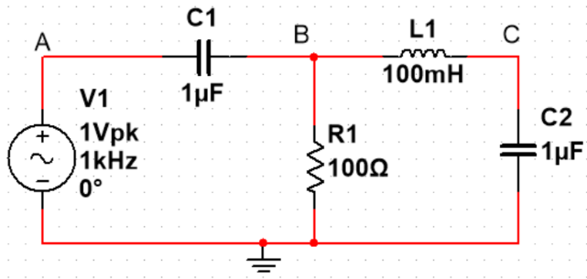

Solutions:

**a) Determine the current through Resistor R1, in the time domain.**

First, convert to phasors. Voltage is , and impedances are .

Now you could use node or mesh analysis, but the fastest is with voltage dividers:



where 

Plugging in the numbers, we get , and , then



and 

meaning the time domain current is 

**b) Determine the Voltage Phasor at node C.**



VC's phasor is  (or -113o instead of -1.96 rad)

**c) Determine the phase of the current through the inductor relative to the voltage *across* it (VB-VC). As well, determine the time difference this corresponds to.**

Inductor current should be 90o *behind* the voltage; i.e., -90o.

(You could just report this one, or demo it using , or using . Or calculate it for this inductor in particular, if you really want to.)

/******check: Can check by taking  then , which give:

 and  meaning the phase of the current through the inductor relative to the voltage across it is -90o.

******/

-90o corresponds to a time *lag* of  or :

The current through the inductor is *lagging* the voltage across it by 250 microseconds.

(could also say "Current lags voltage by 250 " or "Current is behind voltage by 250 ")

## Past Student Advice

Advice from past students:

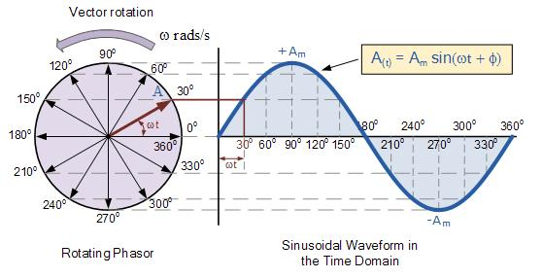

For me, phasors clicked once I could visualize them as vectors (like in the image above). For example, I could better understand how complex impedances are added and what it means for the voltage of a component to lag or lead the current.

If you're looking for another perspective on phasors and AC analysis, I'd recommend watching [Doc Shuster's AC series on Youtube](https://youtu.be/FrRmihdF52o?list=PLLUpvzaZLf3IzKJXgclNlVg8GMBczMBZf) and reading the first year Physics Textbook's chapter on AC circuits.

[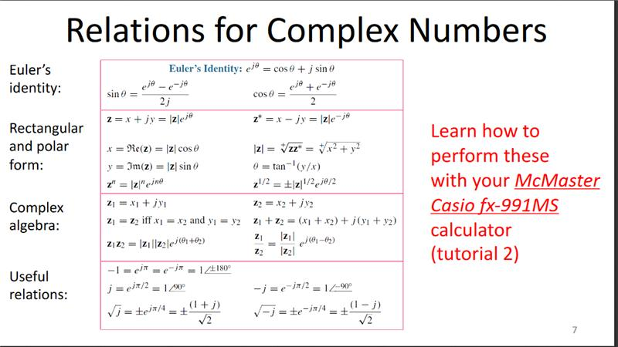](https://us-prod.asyncgw.teams.microsoft.com/v1/objects/0-eus-d9-0be3b373acbcc3fb3f9159f95ddad8b0/views/imgo)

[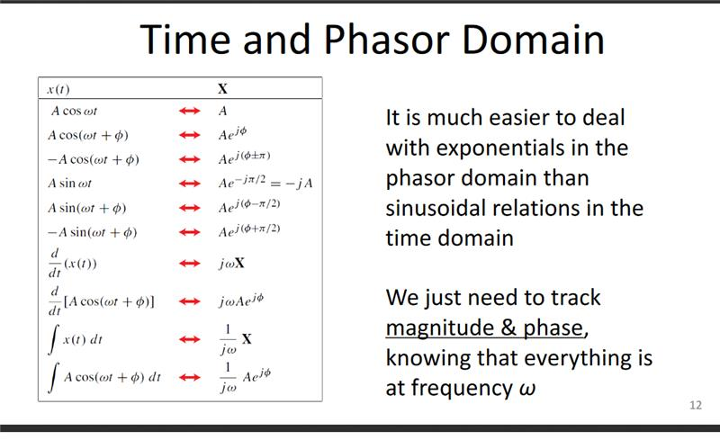](https://us-prod.asyncgw.teams.microsoft.com/v1/objects/0-eus-d20-41874687b3a7522e2e119d3abd0583fc/views/imgo)

[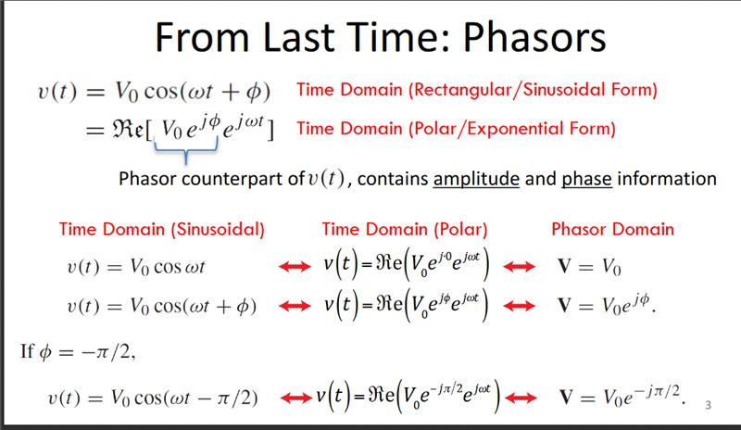](https://us-prod.asyncgw.teams.microsoft.com/v1/objects/0-eus-d5-da76875e0b5d7a16d5ff6a3d530e7cc8/views/imgo)

[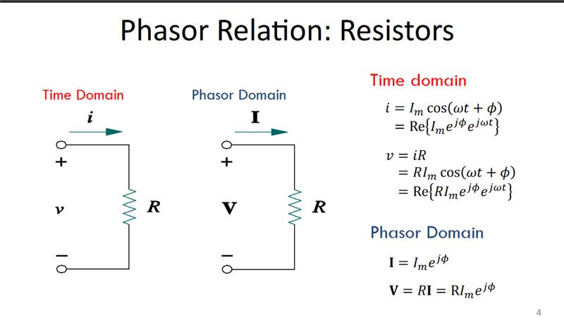](https://us-prod.asyncgw.teams.microsoft.com/v1/objects/0-eus-d20-3f12b43446624e85fb36c445c8a5f285/views/imgo)

[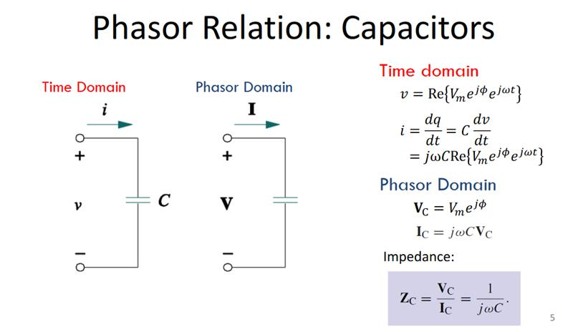](https://us-prod.asyncgw.teams.microsoft.com/v1/objects/0-eus-d19-3f063db9966f25d323e4c5956cc28731/views/imgo)

## Uncertainty of Oscilloscope Measures

Estimating uncertainty when measuring with an oscilloscope can be complicated; see for example

1. <https://www.testandmeasurementtips.com/precision-accuracy-oscilloscopes/>
2. <https://youtu.be/XwTjzjPiRMQ>
3. <https://edadocs.software.keysight.com/kkbopen/understanding-voltage-measurement-accuracy-for-infiniivision-oscilloscopes-584425356.html>

For this course, you can get a reasonable estimate of uncertainty in your measures with the oscilloscope by considering the range of possible measures you could get by how you place the cursors within and around the measurement points; e.g., don't just trust the measure output box; instead, reposition the cursors and try to estimate the range of outputs you'd believe for the voltage difference and time difference you're reporting. e.g., this green signal is not taking up as much of the screen as it could, and is very fuzzy. This will make the reported max and min larger than it should be:

Also note that unless the max and min are the same size, the signal is not centred on 0 so the measure of where it's crossing the axis is going to be off.

The error you would report for this measure would in part be your measurement error of it; namely, how precisely you can read off the plot by positioning the cursors. If you'd believe multiple cursor positions equally well (perhaps because the signal bar itself is wide) this impacts the measurement uncertainty:

Note: you can cut down this error by using more averaging as well (as long as your signal is consistent over your averaging time), but you'll still have limits to the measurement accuracy based on how precisely you can position and read the cursors (and any uncertainty with which the scope measures, digitizes, and reports that data on the screen).

So, uncertainty in how accurately you can *read* the scope's output is at least the larger of the following things:

1. Half the smallest increment if you're confident about the cursor placement



1. Half the **noise threshold** (The range of cursor placements you'd be equally OK with given how fuzzy the signal is)

In addition to this, the scope itself could be displaying the data incorrectly. For this, the answer is very complicated and not always consistent with what you're measuring, but to make it simple, you can take assume it is 5% of any voltage or time reading (but acknowledge that this is an oversimplification).

In conclusion, your scope error is the sum of

1. the error in how accurately the **scope** reports data with its curves (complicated, but take it as 5% of the cursor difference measurement) and
2. the error in how accurately you can **read** those curves
   1. either half of the smallest increment you're using OR
   2. half the noise threshold = half range of values you'd accept if it's larger than half the smallest increment (i.e., the thing you're measuring is so blurry that you'd accept a bunch of possible cursor positions)

P.S., for the AWG, you should trust its opinion of frequency (accuracy is .1% according to the Hantek manual) more than you trust the scope's measure of the AWG's output frequency, but you should trust the scope's opinion of the AWG's output voltage more than the AWG's opinion of it (the AWG has an output impedance of 50 Ω so will likely be loaded by the circuit, dropping its output voltage).